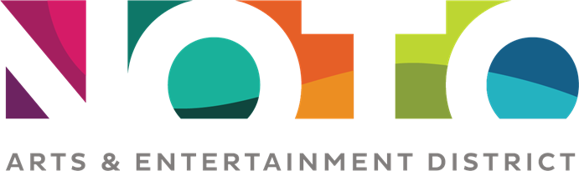
Merchant Discounts and Perks
December 2019 – February 2020

The following are discounts offered by NOTO businesses exclusive to Friends of NOTO.
Additions and revisions to this list are made regularly.
Friends of NOTO

4 Girls Garage 10% off any item.
ACE Plumbing $10 off any type of service
Amused 10% off total purchase.
Donaldson’s Jewelers 20% off all jewelry repairs
Fairie Tale Gardens 10% off total purchase.
Falk Architects Free architectural consultation and 10% off architectural services.
First Class Window Tinting Home and Business "BOGO" Buy one window get one 50% off (applied to window of equal or lesser size)
20% off auto installations (discount does not apply to removals)
Glass Station 10% off regular price items.
Norsemen Brewing 10% off beer or merchandise
NOTO Arts Center 25% off regular price of facility rentals
NOTO Burrito Free drink with burrito purchase
Onyx Salon and Wellness Spa 10% off styling and skincare products
Studio 831 20% off a Barbara Waterman-Peters giclee print or set of notecards
Stutzman Leather 10% off
Pinkadilly 15% off any single item
Round Table Bookstore 15% off any single item
Wheel Barrel Half-price pretzels

