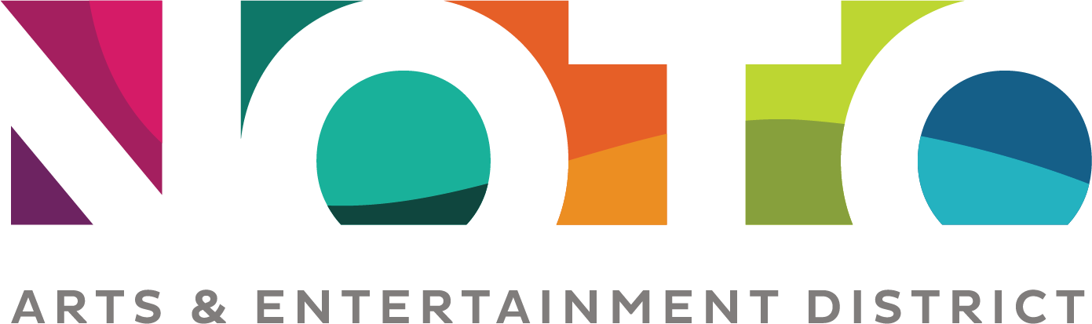

Market Area Vendor Agreement
The NOTO Arts and Entertainment District organization manages locations throughout the NOTO District that serve as market areas, private property were vendors may sell items on the property as part of a market without obtaining a transient permit from the City. Others who are not selling items but rather promoting a cause will be treated the same as a vendor.

The cost of vendor space varies according to location, space requested, and type of vendor. Friends of NOTO receive a 20% discounted price. Payment must be made in advance; space will not be reserved until payment is made in full. Vendors are required to sign an agreement outlining rules and responsibilities. Food vendors must have a Mobile Food Vendors license issued by the City of Topeka.

NOTO events and activities take priority. NOTO reserves the right to cancel a market vendor agreement at any time. NOTO reserves the right to refuse entering into an agreement. Failure to comply with the conditions set forth in this agreement is cause for immediate cancellation of agreement as well as refusal of future agreements.

DATE OF RENTAL: ______________________________
RENTER NAME: _____________________________________________________________________________
BUSINESS NAME: ___________________________________________________________________________
STREET ADDRESS: ___________________________________________________________________________
CITY: ____________________________________ STATE: ___________ Zip: _________________________
PHONE: _____________________________ E-MAIL: _________________________________________
DESCRIPTION OF BUSINESS/PRODUCTS: _________________________________________________________
__________________________________________________________________________________________

Requested Location:
___ Teeter Courtyard at the NOTO Arts Center
___ Redbud Park
___ Breezeway Park
___ Veteran’s Park Parking Lot (food trucks only – projected availability April 2020)
___ Indoor Space (if available)
Requests will be processed on a first come, first serve basis.

Size of Space:
___ Single (about 10’ x 10’)
___ Double (about 10’ x 20’)
___ Food Truck

RENTER accepts the following terms of agreement and responsibilities.
- FEE (Amount) _________
Lease is per day. Payment must be made in advance. Space will not be reserved until payment is made.
- PROPERTY AVAILABILITY
Properties of the NOTO Arts and Entertainment District organization may not be available due to maintenance and construction, special events, or reasons considered necessary and appropriate by the executive director. RENTERS will be notified in advance if the properties are not available unless an emergency prevents timely notification. Liability is for the rental fee only.

- TIME
Space may be utilized between the hours of 11:00a.m. to 9:00p.m. unless otherwise granted by the organization.

- NOTO PERMIT
The RENTER will be issued a NOTO Permit upon payment for a specified location. The permit must be displayed in public view throughout the duration of the use. Note that NOTO has license as a market promoter, so additional permits are not required except for food.

- LOCATION
The RENTER will be assigned a specific location which will be marked with vendor name. The RENTER must remain at that location and may not move to another market location without prior permission by the NOTO organization.

- PERSONAL USE FOOD AND DRINK
The RENTER may bring their own food and drink for consumption during the lease. Alcohol is not allowed for any vendor except for liquor caterers.

- CLEANUP
RENTER agrees to remove all trash, cigarette butts, and other items. Areas not cleaned will be assessed a $50 cleaning charge.

- INDEMNITY
RENTER covenants at all times to hold harmless the NOTO Arts and Entertainment District organization, its agents, owners, and managers from and against all loss, liability, cost or damages that may occur or be claimed with respect to any person or persons, corporation, or property itself resulting from any act done, or omission by or through the RENTER, its agents, contractors, vendors, employees, invitees, or any person on the premises by reason of the RENTERs use or occupancy or resulting from RENTERs non-use, or possession of said property and any and all loss, costs, liability, or expense resulting therefrom; and at all times to maintain premises and the surrounding property in a safe and careful manner. NOTO does not accept any responsibility for damage or loss of any articles or property left prior to, during, or after the event.

- CONTRACT SIGNATURES: This contract constitutes the entire agreement between the NOTO and the RENTER. Signature by RENTER verifies that RENTER has read the contract and understands that any discrepancy, damage or violation of the requirements of the contract may result in the loss of my damage deposit in whole or part. This agreement shall be construed in accordance with, and governed in all respects by, the laws of the State of Kansas, without regard to conflicts of law principles.

COMMENTS:

RENTER: (Print Name): _______________________________________________________________________

SIGNATURE: _____________________________________________________________ DATE: _____________

PAYMENT
_____ Cash _____ Check _____ Credit: VISA Master Card Discover

Card #______________________________________________ CVV # ______________

Name on Card ____________________________________________________________

Expiration Date ______________________

NOTO Arts and Entertainment District
935 N. Kansas Ave Topeka, KS 66608
(785) 408-8996 info@notoartsdistrict.org

