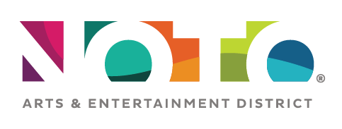
Volunteer
Application

Name
Address
Phone E-mail
If under 18 years of age:
• DOB:
• Name of Parent / Legal Guardian:

Areas of interest (check all that apply):
___ Guest Relations ___ Special Event Support ___ Facility Maintenance

___ Other ____________________________________________________________________________

Availability - Are there certain days or times that you cannot be available? If so, please list:

Restrictions - Are there any conditions that may restrict your work or that special accommodations are needed? If so, please list/describe.

References - Provide name and complete contact information for at least one reference.

NOTO Arts and Entertainment District
935 N. Kansas Ave Topeka, KS 66608
(785) 408-8996 info@notoartsdistrict.org

